Let's Give Students Credit for Summer Learning!
Браво...ви всі молодці!

Браво і поклін усім студентам, батькам, директорові літньої програми, опікунам, учителям, та дирекції Інституту! Літня програма успішно закінчилася і всі студенти зробили чудовий й величезний поступ у мовній частині програми. Подумайте - яке це чудо... На 7-ого липня декотрі студенти почали вивчати мову зі самого початку, з букви «А», а прикінці програми ці самі студенти відважно співали, деклямували і виступали на кінцевому концерті. Під час літньої програми вони глибоко відчули свою українську ідентичність у канадському колі молоді, де було чимало ентузіязму, таланту та енергії.

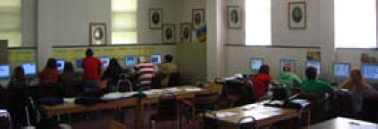
While some students were relaxing at the lake or busy working at summer jobs, thirty-one high school students chose to go to ‘summer school’ so that they could learn new skills while having fun being immersed in the Ukrainian language.

For the past three decades, the Mohyla Institute, a university students’ residence in Saskatoon, has been the site of an intensive summer immersion Ukrainian language and culture program for high school students. This unique program gives students from Saskatchewan and other locations the opportunity to take a five-week high school Ukrainian language course while participating in cultural activities and field trips. During this time, the Institute is transformed into a ‘summer school’ which promotes excellence in language instruction and the cultural arts, including music, dance, choral singing and folk art.

Organized each year by a Summer School Director, student monitors and teachers, the program invites artists, dancers, music specialists and guest speakers from the community to take part in the activities. The program is actively supported by the Board of Directors of the Institute and various local and national community organizations.

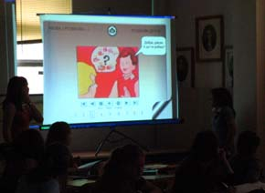
Ukrainian language classes are the anchor of the immersion program. Classes are held for four hours each weekday (for a total of 100 hours of classroom instruction), and are taught by qualified language instructors with Saskatchewan teaching certificates. Courses follow provincial curriculum guidelines, allowing students to obtain provincial credits for Core Ukrainian 10, 20 or 30. Enrichment segments add important information to each course level, focusing on topics such as the pioneer experience in Western Canada, historical events, or cultural traditions which reflect the lifestyle of students of Ukrainian heritage.

This summer’s immersion program was enhanced by the introduction of the province’s new Core Ukrainian 10 online credit course. With the discontinuation of Ukrainian Correspondence Courses, a move toward the development of online course material has become necessary to support language study at the high school level. The provincial online course is available to students through the Saskatoon Catholic Cyber School.

The Grade 10 students who attended the Mohyla summer program piloted the new online course materials. At the end of the course, students were asked to fill out questionnaires about the online instructional components. Their comments were both insightful and encouraging, and will no doubt be helpful in guiding course development for the next two levels. Generally, students were pleased to use technology to enhance language learning:
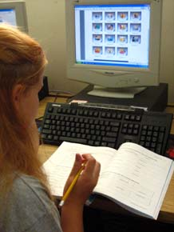
“Overall, I think this program was very good. It helped you learn visually with the dialogues and it helped to be able to look things up and find out different things on your own (using resources online).”

“I found that working on my own was helpful for learning the noun cases.”

“Most helpful overall were the online dialogues. You can listen as many times as you want and this really helped.”

This online Ukrainian language course is the first of its kind in Canada. Perhaps the course will provide a template, or generate some new ideas, for creative approaches to online course development for second languages. However, one positive facet of online learning is becoming clear. As students and parents gain access to language materials online, language learning is extended beyond the classroom into the home environment, where more Ukrainian language assistance is often available. Teachers are more than pleased when students have additional language support from baba and dido, parents or other relatives.

Parents of the Mohyla students must be commended for their support of language learning during the summer months. Most students have full academic schedules during the school year. Some students also attend language programs after school hours or on weekends. These students are committed to language learning, whether their motivation stems from a connection to their Ukrainian heritage or the possibility of future travel, international study or employment opportunities.

Work is currently underway for the development of Core Ukrainian 20 Online. The initial pilot of course materials is scheduled to take place at Mohyla Institute once again during the summer of 2007. Plan to send a student, or pass the message along to other parents who may also be interested!

Nadia Prokopchuk, Ukrainian Education Consultant, Saskatchewan Learning

